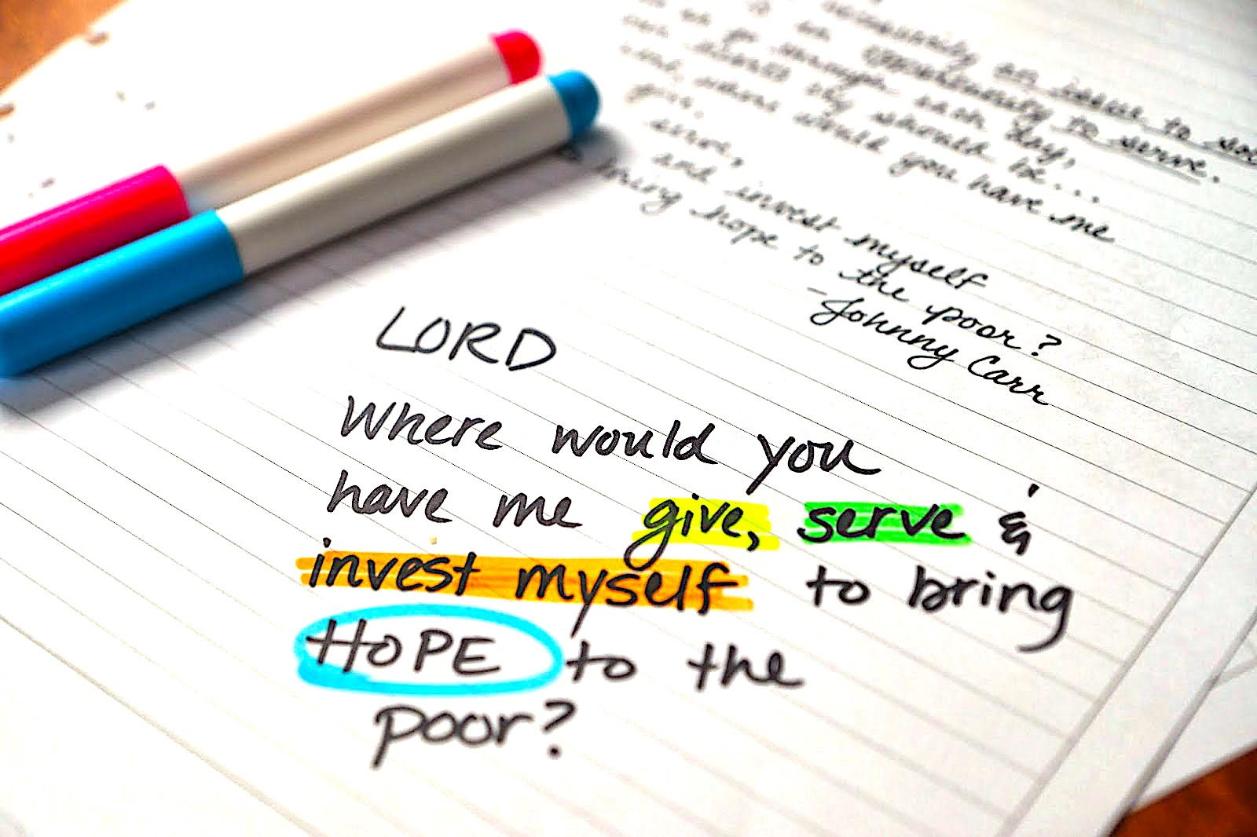
Jesus, What Can I Do? part 2 of 2

Works of Mercy include defending Truth, bringing justice to the poor, explaining God to the ignorant, forgiving those who have offended you, NOT being easily offended, praying for others, sharing what the Word says about the situations they are in. Be kindly and encouraging to those who have been abused.

Every place you can sow peace, love, joy, kindness, patience, good counsel, encouragement, prophecy, praying for the sick, teaching from your experience—every place that needs the light of Christ, you can bring to them by being active in their lives.

We have one gentlemen that is involved with the volleyball team at high school and he witnesses to them. He told me, "My primary thing the Lord is asking me to do is to love people. And to let Jesus shine through me in all of the dark places in the world that need to see Jesus." He works in advertising and shares the Love of Christ with the whole staff.

One thing I’d like to say about the work place. You can have uncommon respect for the employees around you. You can not take offense when they try to hurt you or compete with you. Do good to them when they have scorn for you. Perhaps help them carry something in from their car, or offer to get them a sandwich on your lunch break, or even offer to give them a hand with an overload of work. Mainly, what REALLY slays people, is when you are nice to them although they have deliberately been mean to you. Ask God to give you a supernatural love for them. Be quick to apologize if you offend them or make a mistake. Be the exact OPPOSITE of what they are expecting.

Lord, do you have anything to add?

"I do. When you go out into the world, you are not going out for your own needs, only. You are My ambassador of Light and Healing in this world. You don’t pass by the hurting or homeless—you do something to show your love—because you, My people, are My hands and feet and mouth. What you do may not seem like anything to you, but you have no idea how far down that soul is or if they are contemplating how to end it all. You could be the very last person on Earth that they talk to.

"Nothing happens by chance. Many things are arranged for you during the day, but because you are mostly self-involved (guilty as charged) you don’t see the opportunities I set before you to let that Light shine. You can always shine by being extremely courteous and even patient with someone who is being obnoxious.

"Once you begin to stop living only for yourself, your own interests, your own agendas—and begin to live for Me, I will increase grace inside of you to recognize those in need and so you can minister to them. It begins very slowly, like the lower rungs on a very high ladder. So far, so good. But soon, after days of living selflessly, you begin to get exhilarated from the high of caring for others. You begin to see things you never noticed before, even in your own families.

"This is discipleship, My loved ones. Learning how to love others is truly a college course in selfless love. People are not moved by violent and scathing sermons on a street corner; they run from that. They are moved deeply by a kindness done to them with no ulterior motive. Random acts of kindness. Each act of kindness is another rung on the ladder to Heaven. The higher you climb, the more spectacular the view—until you are seeing what I am seeing and you have My Mind.

"As I see that I can trust you to be humble and little in all circumstances, I can begin to bring knowledge into your lives that you’ve always longed to have. Even the prophetic and healing gifts. You begin very small, but I give the increase in anointing. As I see you treat others with supernatural love, I can begin to send you the harder cases, the more broken ones who no one wants to deal with.

"You become My Ambassador of Peace and people are magnetically drawn to your sincere heart and unpretentious help for them. They see past you and recognize Me living in you.

"Many are looking to serve Me in a greater capacity, in a ministry, but you are not ready. Those who are faithful with the little things will be given the greater ones.

"Clare did nothing but gather food and feed people for 20 years. In the early church, people who saw to the needs of others in this way were called deacons and deaconesses. They served in this way and learned from their elders and then after observing their virtues at work, they were finally ordained to be ministers.

"They were qualified, because they were honest, not self-seeking; they were consistent, showing up day after day in good and bad weather. They prayed for those they served and shared their needs with the rest of the prayer community. Then after a time of observing this kind of virtue, they were ready for greater responsibilities: teaching and admonishing.

"So it is with you, My people. Start small, very small and allow Me to invite you up higher when you are ready. Lower your expectations of what to do to serve Me to the lowest common denominator if you are only just beginning. This is appropriate for you.

"I do not want you to lord it over others with knowledge of Scripture, etc. I want you to come alongside of them with the knowledge of your own failings and shortcomings, and how weak you are—lest you think yourself better than they. I want you to demonstrate My Love in action in their lives. I will do the rest. If you are asked questions, answer as simply and humbly as you can. If they disagree, back off and continue to ply them with My Love. Do not, under any circumstances, break the bond of brotherly love. That will defeat your purpose.

"My disciples must know themselves and know that they are more frail than anyone else they have ever met. This keeps them from presumption and pride—especially the pride that comes with learning. Knowledge does puff up; charity does edify. (that's I Corinthians 8:1)

"There is nothing quite as off-putting as a swaggering, self-proclaiming personality correcting others with an air of disdain. I wish for you to come alongside or even beneath a new believer and allow them to discover Me, giving them little hints here and there and also paying very close attention to their reactions.

"When you do that, you make others feel inferior, like they are not good enough for God. It gives the impression that you have to be smart and all together—and sinless, to be a Christian. When people get this impression, they put off their conversions, feeling unworthy. That is why it is so important for you to be vulnerable and transparent so they can see you are not any better than they are, and yet God accepts you.

"There is an art to drawing souls to Me. Pray for this gift. Love is preeminent. Humility. Remember, these encounters are not happenstance; they are divinely arranged. So be confident that you have the anointing to touch this soul and you know that I am always there with you. My Spirit will speak through you if you give Him the chance. The only prerequisite is Love for others and humility."

